Sponsorship Opportunities for Wandsworth Arts Fringe 2018
4 – 20 May

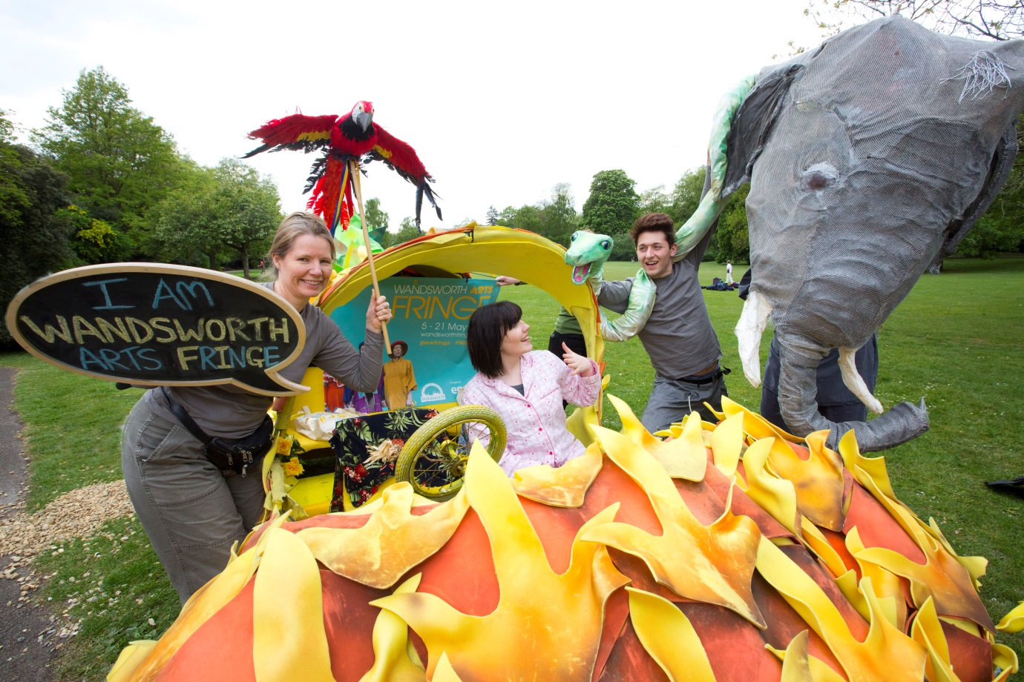
WAF Launch, May 2017 – Photo credit: Ella Lewis-Williams
Fantasy High Street’s What if Machine at St Mary’s Church Square in Putney in May 2016. Photo: Jonathan Vines

Contact: Lelia Greci, Arts Programme Manager
T: 020 8871 7037 E: LGreci@wandsworth.gov.uk

Every year in May, Wandsworth Arts Fringe shakes up South West London with an eclectic programme of arts and culture that thrills, moves and inspires audiences from across the city.

20,000 A5 brochures

65 venues

140 events
13,154 live audiences
317 artists

34,480 broadcast audiences

2,872 participants
224 volunteers

141,782 webpage views

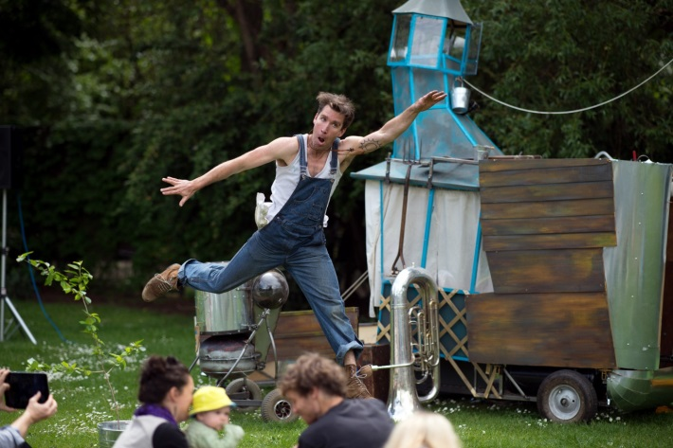

Why sponsor Wandsworth Arts Fringe?

Try something new!
WAF plays a leading role in nurturing local cultural vibrancy and driving community renewal. It acts as a testing ground and market place of new and often experimental work - with artists trying out new ideas, venues attracting new audiences and audiences discovering something different.
Could they discover your brand?

Pif Paf at Hidden Heathbrook, May 2017
Photo credit: Deborah Jaffe

Proud & Local
Wandsworth Arts Fringe offers positive brand association at a local level. Residents are proud of it and many actively participate in it. It is rooted in dynamic local networks of artists, performers, venues, businesses and community groups.

“It makes me feel proud to live in Wandsworth”

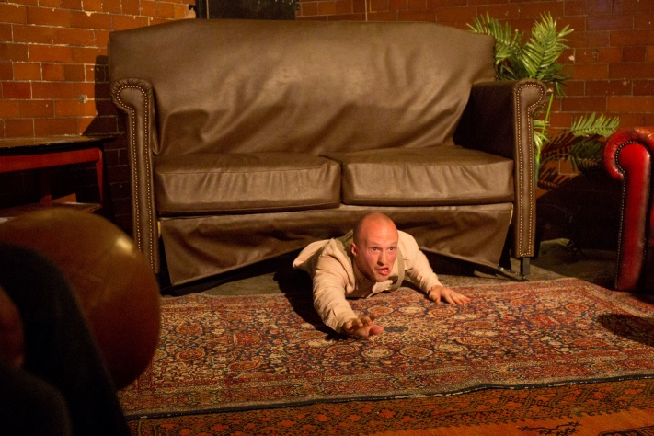
Reach out
The open platform of the fringe and its broad reach, combine the best of professional practice with locally inspired initiatives – penetrating affluent demographics, while also engaging harder to reach groups.
Hoops & Loops at Tooting Tram & Social, May 2017
Photo credit: Belinda Lawley

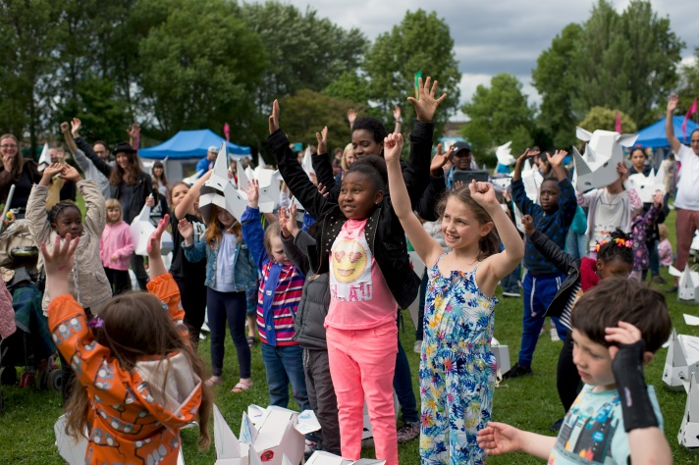
We’re growing!
The festival is growing year on year and promises to flourish into a destination festival, offering something for everyone and inspiring a virtuous circle of benefit – with more artists taking part in a wider range of spaces and venues, attracting larger numbers of audiences.

Puppets with Guts at Hidden Heathbrok, May 2017
Photo credit: Deborah Jaffe

“Left feeling ecstatic, simply fantastic!”

Sponsorship packages start as low as £500!

For more details or to discuss your sponsorship, please contact Lelia Greci,
Arts Programme Manager, on 020 8871 7037 and LGreci@wandsworth.gov.uk

