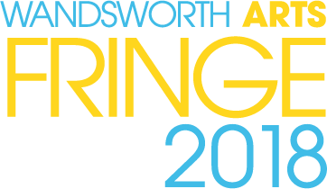 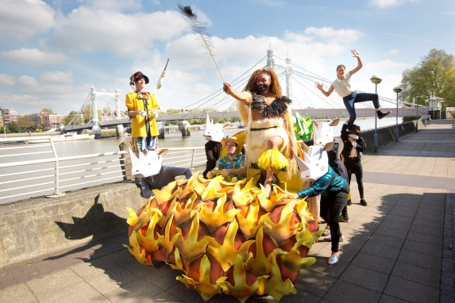 Photograph by Belinda Lawley

Advertising Opportunities

About Wandsworth Arts Fringe

Wandsworth Arts Fringe (WAF) is the highlight of the borough’s cultural calendar.
This annual arts extravaganza has been running for over 13 years and is a much loved fixture, featuring a broad ‘fringe’ programme of home-grown arts and culture alongside high profile visiting artists.
Dates for WAF 2018 are 4 – 20 May.

The Fringe audience
The wide variety of events and activities that take place during WAF attract a broad spread of audiences, both local and increasingly further afield. People are drawn by WAF’s reputation for excellence and the fact it offers something for everyone.
Statistics from Wandsworth Arts Fringe 2017:
- 16,026 audience members and participants
- 140 events spread over 16 days
- 88% of visitors to WAF felt the festival enhanced a sense of community in Wandsworth
- 89% that it was good for the borough’s image
- 95% of visitors said their experience was ‘good’ or ‘excellent’
- 53% travelled under 3 miles
- 19% of the audience said they travelled between 5 and 10 miles
- 18% of the audience said they travelled over 10 miles
- 31% of the WAF audience consider themselves ethnically diverse
- 60% are 35 + professionals.

We work closely with our Fringe partners to proactively develop our audiences – ensuring that we take every opportunity to broaden our reach. Fringe attendees include those who are curious to experience something new as well as those who are already culturally engaged.
Key segments are families, friends of families and community oriented people seeking a good value experience.
The Fringe brochure

This is a high quality, A5, full colour 40 + page publication listing all participating Fringe events.
It is the central communication tool for WAF and provides a comprehensive guide that most of our audiences will refer to at some point, regardless of how they first come to hear about the festival.
A minimum of 14,000 brochures are printed and distributed via us and our partners to venues across the borough and beyond. These include:
- Libraries
- Arts centres
- Galleries
- Cafes and bars
- Leisure centres
- Primary, secondary and special schools

The brochure is also uploaded to the Enable website and to the Fringe website: wandsworthartsfringe.com
Print Advertising Rates (A5, full colour)
FULL PAGE OPTIONS
Back page | £600
Inside front | £500
Inside back | £450
HALF PAGE OPTIONS
Inside front | £300
Inside back | £300
Inside | £300
QUARTER PAGE OPTIONS
Inside | £200

All prices exclude VAT

Please note that back page, inside front and inside back pages are prime advertising spots and always sell early. As such these sites are only available as full and half pages.
Digital advertising

*subject to availability of another quarter page ad

We are offering advertising on wandsworthartsfringe.com for those purchasing advertising in the brochure. Adverts will be visible from March to the end of the May.

Last year the website was accessed by 28,914 users with 141,782 page views during the 11 week ‘on sale’ period (up 126% and 177% respectively YOY).

Please contact the Arts Team (contact details below) for details on advertising on wandsworthartsfringe.com.

We also offer advertising through our email communications as follows:

Email advertising
EMAIL BANNER (to our database of 4,090)
One banner | £50
Two Banners | £100
Three banners | £120
SPONSORED CONTENT (75 words and image)
One feature | £50
Two features | £100
Three features | £120

TO BOOK
Bookings

CONTACT: Hannah Keating – HKeating@wandsworth.gov.uk; 020 8871 8731
DEADLINES: Bookings close 9am Monday 5 February. Adverts must be received by midday Friday 9 February.

Advertising Specifications
All adverts should be supplied as “Press Ready” PDF X1A files.
Full page (A5 portrait) | 148 x 210 mm with 5mm bleed. No trim marks
Half page (Landscape) | 129.5 x 90mm no bleed
Quarter page (Portrait) | 63.5 x 90mm no bleed

