WANDSWORTH ARTS FRINGE COMMUNICATIONS TOOLKIT

Introduction
Welcome to Wandsworth Arts Fringe! We’re delighted that you’re part of this cutting edge, community-focused festival.

This document is designed to give you ideas for promoting your presence at the Fringe. It is written for artists, groups and venues, but some areas will be more relevant to some than others. It will build on the marketing and communications work you will already be doing, and maximize the benefits of being part of the Fringe.

Contents
The document is divided into five sections:
- Audience Development
- Partnerships
- Promotion
- Public Relations
- Logos

Contact us
Please get in contact if you have any questions. Anna Williams is the Arts Marketing Manager and is the best first point of contact.
Anna normally works on Tuesdays/Wednesdays/Thursdays and can be contacted on:
0208 871 5545 awilliams@enablelc.org

Alternatively, if you would like to contact;
Cath Mattos, Fringe producer, please email cathmattos@gmail.com
Lelia Greci, Arts Programme Manager, please email lgreci@enablelc.org

facebook.com/wandsworthartsfringe
Twitter: @WAFfringe #WAF2018
Instagram: @wandsworthartsfringe #WAF2018

Section 1: Audience Development

Here are some key areas to consider when thinking about developing your audience. It’s worth noting that having this information in place will always be helpful for fundraising and grant applications so research your audience as much as you can.

- Who is your current audience?
  - Geographic - where do they live?
  - Demographic - age, gender etc.
  - Psychographic: values, attitudes, interests, lifestyles and opinion
  - Behavioural: What do they do? What do they read? Where do they go? Which venues do they visit? Which events do they attend?
Thinking about the above may identify some opportunities for growth that you may not have considered.

- Who would you like to be your audience?
  - Are you presenting a new work to reach a new demographic?
  - Have you identified an audience base you would like to engage with?
  - Would you like to target a particular component of your existing audience? (e.g. young people)

- Who are your potential partners? They may be local providers or groups reaching the same audience as you.
  - Have a think about what they could offer you
  - How could you link with them? What ‘collateral’ have you got that could be of interest to them? More on this in our ‘Partnerships’ section

- Find out if your marketing has worked!
  - Think about how to evaluate your marketing – this could include feedback forms, box office statistics and conversations. Ask questions that can help you inform your marketing decisions going forward and also help you learn how to improve on your event. For example - ‘how did you hear about this event?’, ‘would you recommend this event to a friend?’, ‘how would you rate this event?’ (on a scale of 1 – 10 with comments).

Section 2: Partnerships

Partnerships provide many benefits, such as promoting your event to a new audience. You may have some partnerships in place already – with certain organisations, services, local networks, venues etc., or you may want to develop some specifically for the Fringe.

Some points to consider when establishing partnerships:
- Identify what you are trying to achieve
  - Do you want to link with other venues or events locally, and start signposting local audiences to each other’s events?
  - Do you want to grow a new audience demographic – for example work with small children? If so, you may want to forge partnerships with people already working in this area.
- What you can offer/what you can ask for
- Partnerships need to be mutually beneficial so make sure that the perceived value of what you offer matches what you ask for. Ideas include:
  - Coverage in print communications (flyers/posters, etc.)
  - Coverage on website
  - Promotion on social media
  - Access to third party database
  - Coverage on e-newsletters
  - Branding at venue/event
- Identify your potential partners. These may include:
  - A media partner (such as Wandsworth Guardian, Nappy Valley.net) can bring significant mutual benefits, such as access to each other’s audiences. Talk to them about what they would like to achieve and how you can access their audience.
  - A venue could provide you with an up-to-date local press contacts list, access to their mailing list, inclusion in their programme as well as knowledge of the potential audience. The Arts Team can give you a list of some venues in the borough of Wandsworth.
  - Other Fringe Participants. Linking with other fringe participants is vital – you can share knowledge, good practice, audiences and marketing distribution. This document will look at this in more detail
- Establish mutual communication
  - Allow time to create your relationship. Have meetings early on to establish a joint campaign. Learn about each others’ work.
  - Be flexible! Flexibility of time and objectives are key to a successful partnership.
- Time and budget (for both partners)
  - Agree your timelines and any projected costs that may be incurred so you can set expectations

Section 3: Promotion

Promotion is how your event is presented or communicated to the target audience. It can comprise advertising, print, press, PR and online campaigns.

It is important that all your posters, flyers and brochures reflect the look of the whole Wandsworth Arts Fringe promotional campaign. It is key to include your branding and the Wandsworth Arts Fringe brand (you can download the logos from wandsworthartsfringe.com/or contact the Arts Team). This association will give your event added credibility and endorsement. It will also help promote other events on the network and direct your audience to the rest of the Fringe marketing material (website, press, brochure, etc.) where they will find more information about your event.

Social media
Plays a big role in promoting WAF. We operate across the three main platforms- Twitter, Facebook and Instagram, with strong followings across each.
Twitter:
- Our Twitter page is at twitter.com/WAFfringe.
- We have 2.5k followers
- Tag us in your posts @WAFfringe
- Use our hashtag #WAF2018- by using our hashtag you can be listed with other participants and people will be able to find you easily.

Here is a list of suggested tweets. Where possible insert a picture and a link (e.g. to your listing, ticketing site or your own website- shorten the url):

We’re getting ready to take part in #WAF2018

We will be presenting (NAME OF YOUR EVENT) at (NAME OF VENUE – LINKED) on (DATE) get your tkts (WEB ADDRESS) #WAF2018 #(AREA: i.e. TOOTING)

15 tickets left! You know you want to. Grab the final here (LINK) #WAF2018 #(AREA) #(VENUE)

We got our printed material! Very excited (attach image) #WAF2018

- Shorten your links using a url converter e.g. https://bitly.com/

- If you have videos, you can create a YouTube channel or Vimeo channel and link your account with the WAF account to replicate the message and have a bigger impact

Instagram:
Instagram is a great place to post pictures and videos, and it is free to create an account.

- Follow us @wandsworthartsfringe
- Tag us in your posts
- Use hashtag #WAF2018 when you’re posting.

Send us your rehearsal photographs to arts@enablelc.org and we will be happy to post these on our social media accounts.

Facebook:
- Follow us facebook.com/wandsworthartsfringe
- This is where we post images and videos, promote the Fringe, and link with other participants. Please tag us so that we know what you are doing!

SO- TOP TIPS!

Remember to:
- Tag us in your posts, so you can promote the fringe/ our social media pages to your audiences!
- Use the correct hashtag #WAF2018

And…
- Sites like Facebook, Twitter, YouTube or Instagram work very well to promote your event but these need to be kept updated with regular stories/information. Think about the kind of content you are posting and consider what could ‘go viral’ (i.e. generate enough interest from your followers that they forward your post).
- Keep this commitment in mind before creating your profiles so you don’t create more accounts than you can handle. The interaction between users and your company is key so having at least one team member responding and updating them is ideal.

Other online tools
  - Newsletters and email marketing
    - If you have a good email database you could use it to update people about your event. There are some free providers such as Mailchimp and you can design a friendly user email that reaches your audience. This should be branded with your image and we strongly suggest also with the Fringe brand.
    - Hoop is an app that lists family friendly events and activities happening across town. It is free to create an account, and great for you to list your own event for WAF 2018.
- Last year Hoop highlighted 13 events that are fab for families, of which three were WAF events! 7% of WAF’s audience say they found out about the event they attended through Hoop!

Advertising (any paid form of communication)
Advertising can be very expensive and not very targeted. If you do want to use paid advertising you should get clarity on:
  - The reach of the publication or site (i.e., what is the circulation /how many unique users)
  - Where you advert will be featured (to make sure it doesn’t get missed)
  - When the advert will be made public

- Advertising contacts

Here are contact details for advertising in various local newspapers/magazines/ websites. Most printed publications will have a related website. Note: these are fairly general publications and you may also want to research/consider more niche ones.

Company | Name | Email
Newsquest  (Wandsworth Guardian/Wimbledon Guardian/Kingston Guardian etc) | Advertising Queries | slg.ads@london.newsquest.co.uk
Capital Media Newspapers Ltd  Pulse/SouthLondon Press | Candy Brown | Candy.Brown@slp.co.uk  https://www.londonnewsonline.co.uk/meet-the-team/
The Art Newspaper |  | http://theartnewspaper.com/contact/
Archant (local magazines including SW Resident) |  | archant@mediaforce.co.uk
Nappy Valley | Annabel | annabel@nappyvalleynet.com
Time & Leisure – Wimbledon/Wandsworth/ Putney and Barnes | Tracey Richardson | tracey.richardson@timeandleisure.co.uk
Time & Leisure- Clapham/Battersea and Fulham | Michelle Morgan | Michelle.morgan@timeandleisure.co.uk
Eve Standard and Metro |  | immarketing@ukmetro.co.uk  http://metro.co.uk/2017/03/24/useful-numbers-2-4164977/  http://moremetro.co.uk/contact/useful-numbers/
Impact Poster distribution | Ava Striker | 0207 613 8402. ava@impactideas.co.uk
WandsworthSW18.com |  | info@neighbournet.com
Updated August 2017

- Online advertising
In addition to the contacts mentioned above, you may want to consider:

- Online ads: See table above. Also, most social platforms (such as Twitter and Facebook) offer advertising to promote your content. Consider carefully the impact this could have within your campaign and if it is the best way to reach your audience.
- Online listings - here are examples of listing websites (some are also printed publications) where you can either upload your event for free, or pay for a listing. You will need to create your own account in each one you want to use.

- Artforum
- Art Rabbit
- Art Monthly
- Artslant
- Contemporary Art Daily
- Critical Network
- Culture 24
- Daily Telegraph
- Don't Panic
- Engage
- Families Magazine SW
- Guardian Guide
- Hoop
- I send you this
- Skint London
- Mumsnet
- Pictify
- Primary Times
- OOKL
- Remote Goat
- Resonance Fm
- RA Magazine
- Press Association
- Putney Social
- Spoonfed
- The Art Newspaper
- This is London
- Time Out London ARTS
- Time Out London Things to Do
- Urban Explorer
- View London
- Visit London
- Wandsworth SW18
- Lets go with the children

Updated August 2017

- Display media (Posters, flyers, pamphlets and brochures)
- Where and how will these be distributed? – there are companies that provide delivery of events flyers and posters, such as Don’t Panic and London Calling.
- If you decide to distribute your own printed material it’s important to have a structured plan:
    - Who is your audience and where can you find them? (Cafes, schools, libraries, local businesses, GP surgeries, etc.)
    - Create a database of where posters can be placed. This can be referred to and updated in years to come.
    - Collect information about the display venue and get permission to send your promotional material. Develop a relationship with a specific point of contact.

Section 4: Public Relations (PR)

Press Releases
To generate editorial coverage for the festival, the Arts Team will write and distribute dedicated WAF press releases. These will promote the Fringe programme as a whole, inviting journalists to find out more about the single events.

It is key that you coordinate your own PR campaign to secure editorial coverage for your own event. Write a press release to send to journalists. You will need to create a ‘story’ – a ‘hook’ that will generate their interest.
It is also a good idea to build relationships with journalists, don’t just email – call if possible, and invite them to your event to create long-term relationships.

For your press release:
  - Keep in mind that journalists receive many press releases per day so ideally send something with a catchy title with clear and concise information so they can quickly get all the information they need. Usually they are 450 word long max
  - Bullet points are a good way of clearly disseminating key information.
  - Remember to create a ‘hook’ that will generate interest. What story can you tell? Human interest can be a good point of interest.
  - Use the 5 Ws to write your press release: What, Where, When, Why, Who
  - Ensure the press release includes key information: description, prices, dates, location and contact details.
  - Use quotes that journalists can use in their pieces (visitors, artists, audience)
  - The best way to send press releases is by email. You could also have some printed if you are expecting journalists to attend your event.
  - Only use real information and facts
  - Check the grammar and spelling before sending it
  - Avoid clichés
  - Have a media list to pitch your story (you can include the ones provided above)
  - Have high and low resolution images and logos with the full credits. Tell press that you have them available in case they need them. Perhaps send a low resolution image in your first email to grab their attention.
  - Online tools such as Dropbox or wetransfer.com allow you to distribute your larger files (such as high resolution images). Let the journalists know if you will be sending your images via any of these.

Here are a few editorial contacts to get you started. Note, these are quite general publications and you may want to include more niche publications.

Name | Publication | Email
Chris Caulfield | Wandsworth Guardian  Content Editor - Richmond and Wandsworth | chris.caulfield@newsquest.co.uk
Sarah Kingsley | Totally Clapham | sarahkingsley@totallyclapham.co.uk
Sandi Bloomfield | Putneysw15.com | editor@putneysw15.com
Louise Salmon | Wandsworthsw18.com | editor@WandsworthSW18.com
Francesca Young | London Town | francesca@londontown.com
Fiona Hughes | Standard | fiona.hughes@standard.co.uk
Stephanie Siegle | Time and Leisure | stephanie.siegle@timeandleisure.co.uk
Shujaul Azam | South London Press | shuz@slp.co.uk

Updated August 2017

Word-of-mouth
  - Word-of-mouth is often the most common way people hear about events.
  - If you have many dates during the Fringe weeks, it is key that you sell the first dates, that way it will be easier to create a buzz.
  - You can offer discounts for the opening, or 2 for 1 for the previews – maybe offer them through your social networks or as early bird offers, or as Buy One Get One Free.
  - There are many opportunities to promote your event, such as meetings, gatherings, etc., so always keep your event and the Fringe in mind. Talk about your event whenever you can and always invite people to visit the Fringe website for more information. Try to keep some printed material with you (flyers, Fringe brochures, invitations, etc.) to distribute at an opportune moment.
  - Take advantage of the platform provided by the festival launch event to promote yourself and your activities across networks including local VIPS, arts industry and community – by showcasing your offer and inviting your own contacts.
  - Where possible, distribute WAF brochures in your venue.
  - Champions - consider asking your board or volunteers to promote your event to a group of 10 people. This way these people will do the same through their networks and it is easy for the message to become viral.

Staff and volunteers
  - It is important that your staff, artists and volunteers are fully briefed on your activity and are aware that you are part of the Wandsworth Arts Fringe. They will be the first point of contact for audiences, partners and stakeholders.
Section 5: Logos

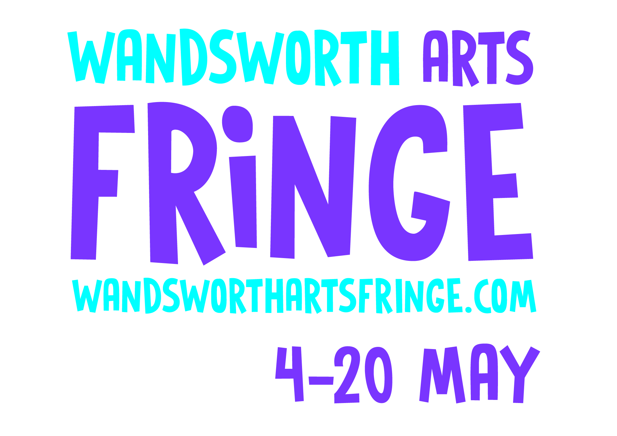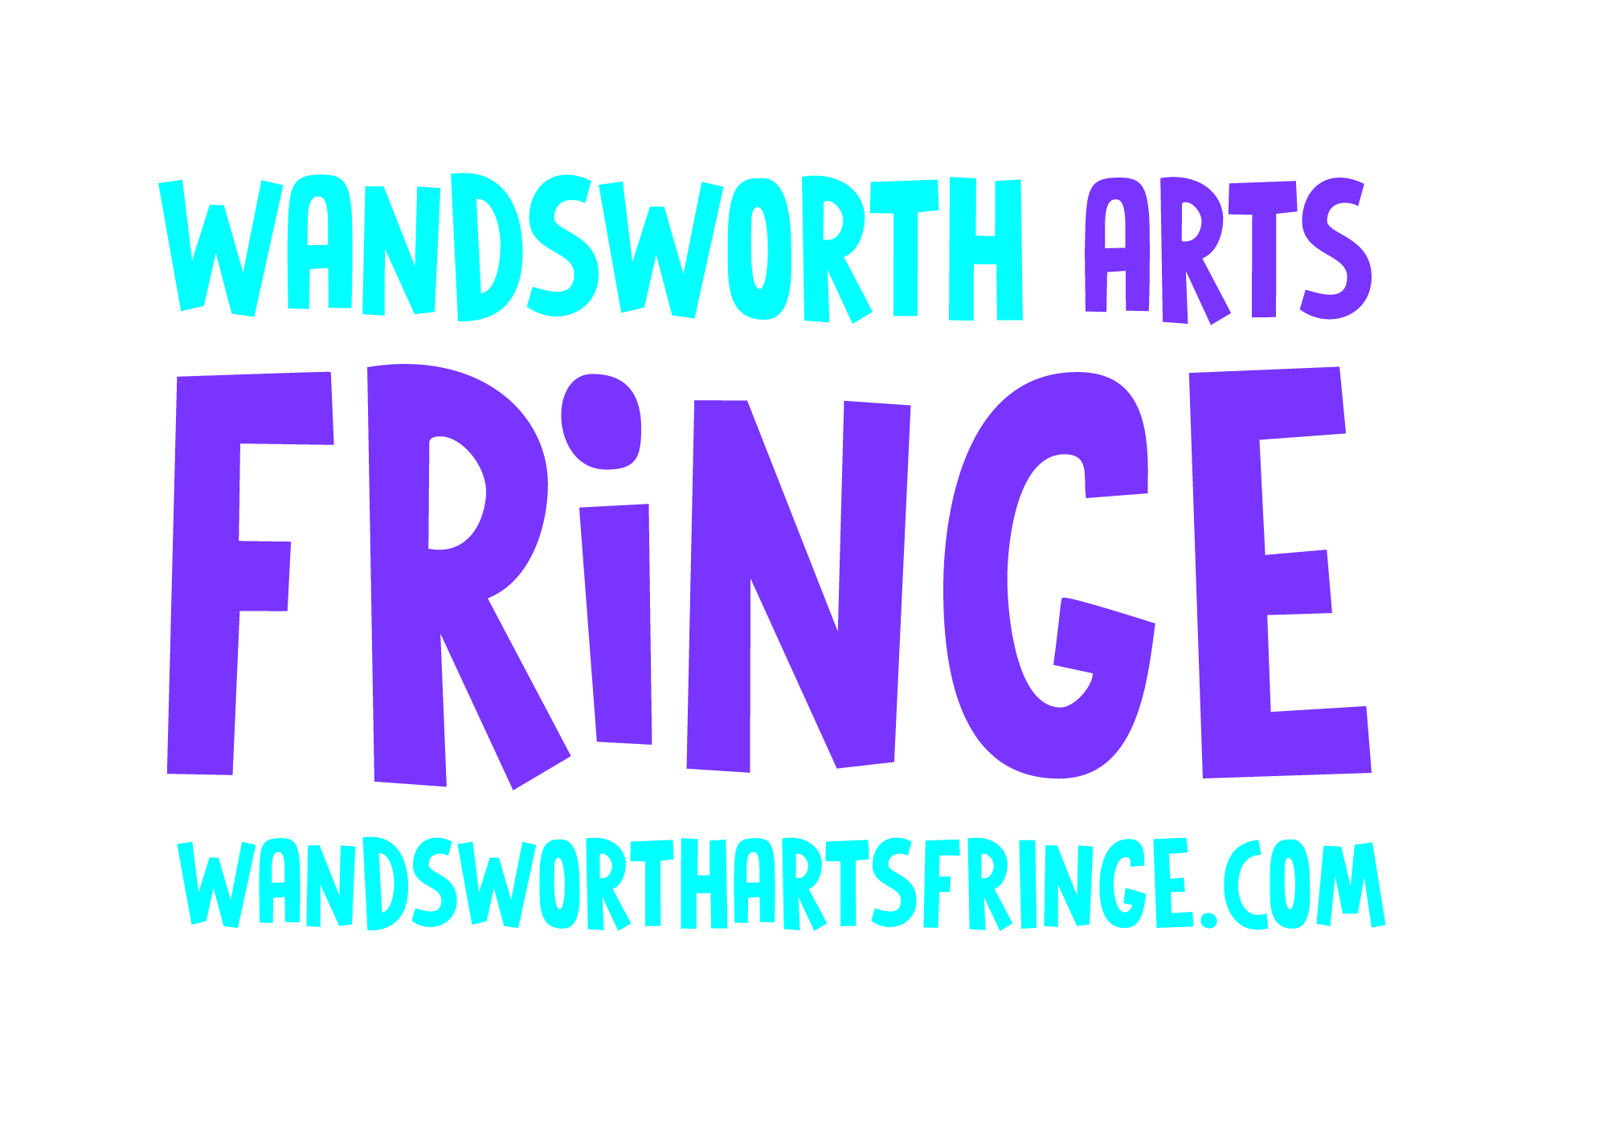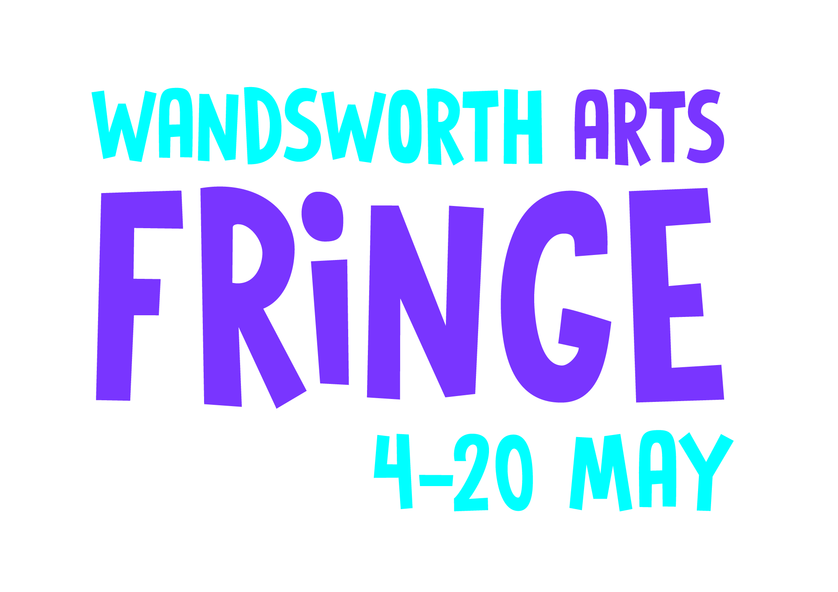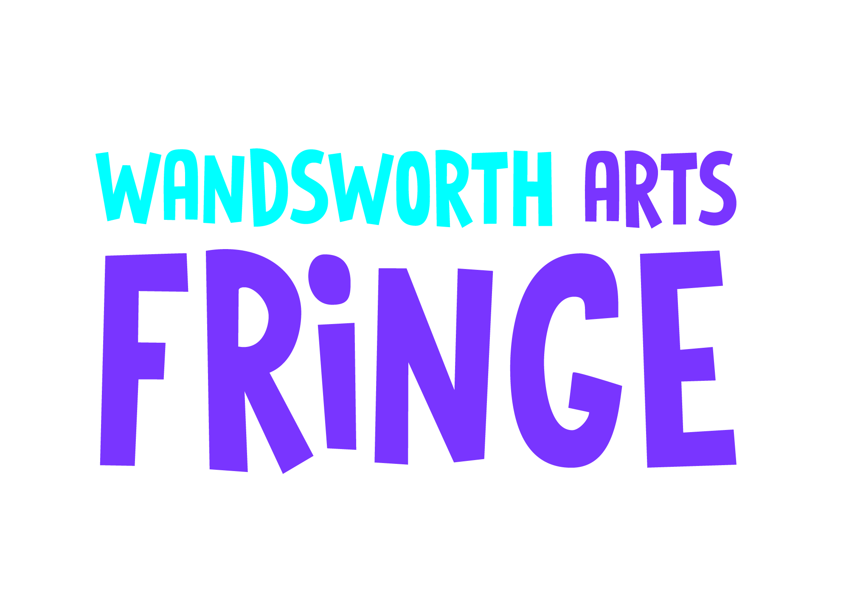

Please use the Wandsworth Arts Fringe 2018 logo on all of your marketing communications.
For high resolution logos go to www.wandsworthartsfringe.com or contact Anna Williams from the Arts Team at awilliams@enablelc.org

